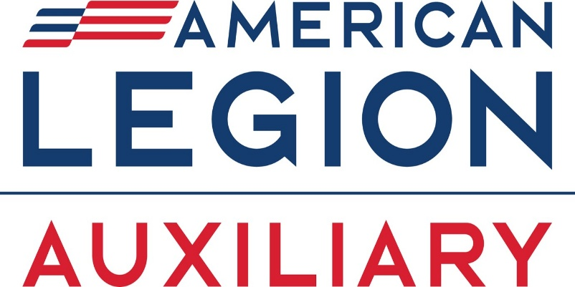

DISTRICT 4
101ST CONVENTION
BOOK OF REPORTS
MARCH 22, 2025
POST 5
EMPORIA, KANSAS

SHOW KINDNESS EVERY DAY TO EVERYONE

TABLE OF CONTENTS
Contents
THE PLEDGE OF ALLEGIANCE TO THE FLAG 4
STAR SPANGLED BANNER 5
PREAMBLE TO THE CONSTITUTION 6
DISTRICT FOUR OFFICERS – 2024 – 2025 7
DISTRICT 4 CHAIRMEN 2024-2025 8
DISTRICT OFFICER REPORTS 9
PRESIDENT’S REPORT 10
VICE PRESIDENT’S REPORT 12
SECRETARY/TREASURER’S REPORT 13
CHAPLAIN’S REPORT 14
DISTRICT CHAIRMAN REPORTS 15
PUBLIC RELATIONS 16
VETERAN AFFAIRS & REHAB 16
NATIONAL SECURITY 16
LEGISLATIVE 17
CONSTUTION & BYLAWS 17
COMMUNITY SERVICE 17
LEADERSHIP 17
EISENHOWER 18
AMERICANISM 18
POPPY 19
LIAISON – CHILD WELFARE 19
AUXILIARY EMERGENCY FUND 19
ORATORICAL 20
GIRLS STATE 20
PAST PRESIDENT PARLEY 20
MEMBERSHIP 21
JR. ACTIVITIES 22
CHILDREN & YOUTH 22
EDUCATION 22
Unit #38 – Burlington – President’s Report 24
CREDENTIALS REPORT 2024-2025 27



THE PLEDGE OF ALLEGIANCE TO THE FLAG
I pledge allegiance to the Flag of the United States of America and to the Republic for which it stands, one nation under God, indivisible, with liberty and justice for all

STAR SPANGLED BANNER
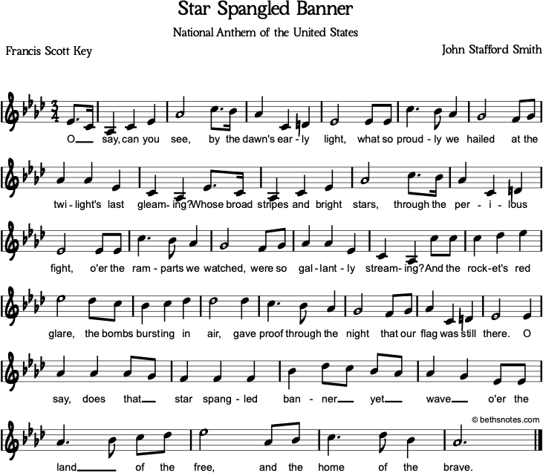

PREAMBLE TO THE CONSTITUTION

“For God and Country, we associate ourselves together for the following purposes;
To uphold and defend the Constitution of the United States of America;
To maintain law and order;
To foster and perpetuate a one hundred percent Americanism; to preserve the memories and incidents of our association in all wars;
To inculcate a sense of individual obligation to the community, state and nation;
To combat the autocracy of both the classes and the masses;
To make right the master of might;
To promote peace and goodwill on earth;
To safeguard and transmit to posterity the principles of justice, freedom and democracy;
To participate in and contribute to the accomplishments of the aims and purposes of The American Legion;
To consecrate and sanctify our association by our devotion to mutual helpfulness.”

DISTRICT FOUR OFFICERS – 2024 – 2025
PRESIDENT | SERGEANT AT ARMS
Carol Roush 632 W. 245th St.  Lyndon, KS 668451-9643  785-640-3319 croush54@hotmail.com | Janeine Muir  504 Holly Ln  Newton, KS 67114  620-755-9682  janeinemuir2018@yahoo.com
VICE PRESIDENT | PARLIMENTARIAN
Marcia Cottrell 1225 Adams St.
Lyndon, KS 66451 785-817-7591 marsh6719@hotmail.com

SECRETARY/TREASURER | 3-YAR EXECUTIVE COMMITTEEMAN
Kay Busby  1137 N. Elm  McPherson, KS 67460  620-755-1726  kbusby4343@gmail.com | Marcella McGuire  1115 Rural St  Emporia, KS 66801  620-340-2978  marcellamcguile@yahoo.com
CHAPLAIN | 2-YEAR EXECUTIVE COMMITTEEMAN
Donna Mendoza  304 W. 6th  Lebo, KS 66856  620-356-5950  danddmendoza@yahoo.com | Liz Reinsmith  2208 W. 7th Apt 2  Emporia, KS 66801  206-491-4213  errst@yahoo.com
HISTORIAN | 1-YEAR EXECUTIVE COMMITTEEMAN
Marjorie Lewis
PO Box 301
Lebo, KS 66856

jlewisks@yahoo.com

DISTRICT 4 CHAIRMEN 2024-2025

Carol Roush – 632 W. 245th, Lyndon, KS 66451 785-640-3319 croush54@hotmail.com
Poppy Americanism Eisenhower Liaison to Child Welfare

Marcia Cottrell – 1225 Adams, Lyndon, KS 66451 785-817-7591 marsh6719@hotmail.com
Oratorical Girls State Past President Parley Membership

Kay Busby – 1137 N. Elm, McPherson, KS 67460 620-755-1726 kbusby4343@gmail.com
Legislative Const. & Bylaws Community Service Leadership

Janeine Muir – 504 Holly Ln, Newton, KS 67114 620-755-9682 janeinemuir2018@yahoo.com
National Security VA&R Public Relations

Marcella McGuire – 1115 Rural St, Emporia, KS 66801 620-340-2978 marcellamcguile@yahoo.com
Jr. Activities Children & Youth

Janet Lewis – PO Box 301, Lebo, KS 66856
Education

Donna Mendoza – 304 W. 6th, Lebo, KS 66856 620-356-5950 danddmendoza@yahoo.com
Auxiliary Emergency Fund



DISTRICT OFFICER REPORTS

PRESIDENT’S REPORT
2024-2025 – Carol Rouch

I began my year as President on April 13, 2024, at our District Convention held in Emporia Post 5 where I was elected and later installed in Topeka at our Department Convention.

My first meeting was on July 8 for an E- board meeting. We discussed our plans, budget, and officers for the upcoming year. Also, discussion regarding the need for fund raising for the district. August 10, I attended the Department President homecoming in Hutchinson.

Attended Department Convention in Topeka May 31 —June 2 where I was installed as 4th District President.

September 4, we held another DEC meeting in Lebo. We chose committee chairmen at this meeting.

September 9, I attended the Burlington unit meeting and assisted theme with any issues they had.

September 15, l, along with my husband and other 4th district legion and auxiliary members worked the American legion booth at the Kansas state fair. This was an enjoyable day.

October 1, I traveled to Peabody to meet the ladies there at their meeting. Quite an active unit.

October 5, I traveled to Derby for the Department Fall Conference.

October 10, I volunteered for the Coffey County government day in Burlington. This is always a very enjoyable day with all the students.
October 12 traveled to Abilene to the Eisenhower Pilgrimage to lay the 4th District wreath. Afterward, attended the homecoming for Department Vice President and Department Vice Commander.

On October 22, I visited with the Emporia Unit 5 ladies at their meeting. Prior to the meeting, there was a joint dinner with the legion with steak and the works. It was delicious.
October 26 homecoming for myself and 4th district commander, my husband, Danny Roush in Lebo. The meal was delicious, and we had a packed crowd.

November 2, I attended my first mouse races event in Burlington. This was amazing and a lot of fun. Looking forward to the next one.

On November 11, Veterans Day, I assisted with Post 125, Lyndon annual Chili/soup feed.

November 15 took a truck load of donated items to the Topeka VA for the upcoming gift shop.

November 19, I attended the Hillsboro unit meeting. Great to meet these ladies and they are a busy unit.

December 4, I volunteered at the Topeka VA gift shop. This gives me such joy to help these veterans.

January 13, 2025, I went to Burlington unit meeting to assist them with their reports.

January 31-February 2 attended Mid-Winter Rally in Great Bend.

Well, the year has been exciting, and I enjoyed visiting some of the units and getting to meet a lot of the members. This has also been a good learning year for me.
I wish the next president a great year. I think I am ready to take a break after 3 years of being President.

Thank you all for your help and support.

VICE PRESIDENT’S REPORT
Marcia Cottrell
It’s hard to believe this year is coming to a close already. It just seems like yesterday that
we were attending our final original District 4 Convention. It has been a great year and a
building year for the new District 4.
My year started April 13, 2024, at our District convention held at the Emporia Ball McColm
Post #5 where I was elected and then installed in Topeka at our Department Convention.
Our first District Board meeting was in Emporia where the District officers met to go over
our President’s theme, budget and discussion of what we need to do to have a successful
year.
I attended Eisenhower Pilgrimage in October in Abilene. The day was beautiful, and I had
the honor of laying the rose for my Unit 323. This is always a beautiful ceremony and one I
so, enjoy attending.
On October 26, 2024, I attended the District IV homecoming at Lebo. We had a wonderful
turn-out and everyone enjoyed the afternoon. Attending were representatives from the
Department and several other Districts.
This year I did not get to attend as many Department events as I normally do because of
having knee replacement surgery which put me on the “disabled list” for about four (4)
months. But I am back to pretty much normal and able to attend various events again. I
want to extend a huge thank you to all of the District members that sent cards, were there
to act as chauffeur, kept me your prayers and called or texted to check on how I was doing.
That is so truly Auxiliary Sisterly Love, and I really appreciated it.
District 4 now has 12 Units and are doing wonderful in membership renewals. Thank you
to all of our Unit Membership Chairs for your help in getting your renewals submitted
promptly. As we all know, “there is no I in team” and we are definitely a team in this
endeavor and always will be.
Marcia Cottrell
District 4 Vice President 2024 – 2025
In the Spirit of “Service Not Self” for our Veterans, God and Country

SECRETARY/TREASURER’S REPORT
Kay Busby

What a year it’s been so many changes for our district but all good changes. Our first e-board meeting was held at Emporia in July and we had a lot to discusses. Approving our budget, getting the 990 current, district bond current but the biggest was choosing our new bank. With much discussion the decision was made to go with the ESB Financial.
Our per capita “invoices” were sent to each unit president at the end of July and I’m proud to say we got them all back really fast. Maybe having the “invoice” was a good idea, not getting mixed up with the unit’s other business matters. At this writing our balance on hand according to the bank statement dated 2-28-2025 is $ 1,328.80. We are smaller but I feel like we are going to be strong may take us a while but we’ll get there.
It’s been a great year and I’m happy to be a part of this district and serving in a new position as the secretary/treasurer. Thank you Carol and the district 4 members for allowing me this honor. I’m looking forward to serving our district again in this position in the coming year and hopefully without all the roadblocks we accounted this year.

As for the secretary position it’s also been a learning year for me. I did help Carol with the Call to Convention and the book of reports. I’ve always been pretty “organized” but this year has really brought out the organization mode in me. I loved helping Carol and look forward to serve again.

Thank you district 4 for a great year.

Kay Busby

CHAPLAIN’S REPORT
Donna Mendoza

NO REPORT

DISTRICT CHAIRMAN REPORTS



PUBLIC RELATIONS
2024-2025
Janeine Muir – Chairman

Three units reported that they use social media and Facebook for letting the public know of any activities that they are supporting.

VETERAN AFFAIRS & REHAB
2024-2025
Janeine Muir – Chairman
The information that was provided states that we had 130 hours with a cost of $4,319.00 traveling 170 miles and serving 25 plus veterans. Those activities included giving to our VA gift shops and fixing and serving meals at their post. Also placing flags at the local cemeteries.

NATIONAL SECURITY
2024-2025
Janeine Muir - Chairman

Out of the 12 units only 4 reported with three units stating that they have nothing to report. The other unit reported that they had 20 hours with an expense of $45.00 and traveled 165 miles by donating blood.

LEGISLATIVE
2024-2025
Kay Busby – Chairman

This is so sad that only one unit stated that they went out to VOTE this year. And she waited only a short time to place her vote into the ballet box.

CONSTUTION & BYLAWS
2024-2025
Kay Busby – Chairman
Two unit reported that they are working with a committee to update their unit Constitution & Bylaws. Seven (7) hours and twenty-five (25) miles.

COMMUNITY SERVICE
2024-2025
Kay Busby – Chairman

Seven hundred seventy-six (776) hours were spent taking neighbors, friends and veterans to doctor appointments and helping with dinners at their post along with hosting a dance and corn hole tournaments. This cost was $1,262.80 with 705 miles driven.

LEADERSHIP
2024-2025
Kay Busby – Chairman
Units that reported stated that they had 246 hours with a cost of $25.00 and traveling 314 miles to attend unit meetings, district and department functions.

EISENHOWER
2024-2025
Carol Roush – Chairman
One unit reported that they participated in the Eisenhower with 30 hours and driving 480 miles.

AMERICANISM
2024-2025
Carol Roush – Chairman
200 miles were driven to support 30 veterans. Activities that were included were participated in the 4th of July parade, attended and participated in Memorial Day ceremony and attending Flag Retirement ceremony. Members fly an American Flag at their homes 24/7. Over 200 small flags are placed by members at local cemeteries during the Memorial Day weekend. A Flag Retirement ceremony was held at the Veterans Day Ham & Bean dinner.

POPPY
2024-2025
Carol Roush – Chairman
Five (5) hours were spent assisting 4H Club with Poppy distribution and traveling 45 miles. Unit members of the Gridley unit decorated the library window for 30 days during the month of May with Poppy and Memorial Day items. Poppies are used in community Veterans Day dinners. A $202.68 donation was given to the Department office for the Poppy Fund. $50.00 was spent in refreshments & decoration.

LIAISON – CHILD WELFARE
2024-2025
Carol Roush – Chairman
Units that reported stated that they do not participate in this.

AUXILIARY EMERGENCY FUND
2024-2025
Donna Mendoza – Chairman
Ten (10) hours were reported with 10 miles being driven. Summary of activities that were done was a “fine” for various infractions at unit meetings and the “fine” was given to the AEF fund.

ORATORICAL
2024-2025
Marcia Cottrell – Chairman

NO REPORT

GIRLS STATE
2024-2025
Marcia Cottrell – Chairman

Out of the twelve units within our district only one reported that they sent a delegate to Sunflower Girls State. Ten (10) hours were worked with 50 miles driven. The unit worked with the school counselor and presented the program to the girls during school. This seemed to create an interest in this program.

PAST PRESIDENT PARLEY
2024-2025
Marcia Cottrell – Chairman

There are 12 Units within our district and only 1 unit reported that they spent 9 hours working and spent $30.00 and traveling 30 miles. Summary of activities were made peanut brittle for family and friends.

MEMBERSHIP
2024-2025
Marcia Cottrell – Chairman

Three (3) units out of our twelve (12) reported that the traveled 100 miles and worked 20 hours by processing memberships, provided membership reports at their unit meetings, processed transfers, along with deceased members and sent membership cards for renewing members.

JR. ACTIVITIES
2024-2025
Marcella McGuire – Chairman

NO REPORT

CHILDREN & YOUTH
2024-2025
Marcella McGuire – Chairman

NO REPORT

EDUCATION

2024-2025
Janet Lewis – Chairman

NO REPORT

UNIT PRESIDENT’S REPORTS



Unit #38 – Burlington – President’s Report

Dear District 4 President,

What another year has gone by. The American Legion Auxiliary has been busy. The Auxiliary helps the men with a chili soup feed at our local High School to raise money. The Auxiliary helps the men with our once monthly feeds. The Auxiliary brings baked good to the monthly feeds. In May the American Legion held our annual BBQ feed what a big successful turn-out. In July the American Legion had another successful firework stand. The American Legion and the Auxiliary worked together in another successful year selling poppies. The Auxiliary did donations at the end of the year. Looking forward to see what 2025 will bring.

Shatosha Barnard
Post 38 Auxiliary President

HAROLD “SKINNY” SPATZ UNIT 323
Highlights of Our 2023-2024 Year
We have had a great year! Our members work together on any and all projects and are
always there for one another all the time.
We assisted with our Memorial Day Ceremony this past year, by placing a poppy on the
ground in a circle around the flagpole at the cemetery. There are 500+ names that are
read of those that we have lost throughout the years. The appearance of the poppies on
the ground in a circle is really impressive.
The Blue Ribbon 4-H Club in Lebo assisted with poppy distribution by going door to
door collecting donations for Poppy Day. They assist us every year with this as part of
their community service hours.
We participated in the July 4th Parade by building a float with the assistance of some of
our Unit members. We also participated in the July 4th Festival by members contributing
homemade baked goods to be distributed during Bingo. We had a successful fundraiser
as a result.
Several members of our Unit attended Eisenhower Pilgrimage this year to lay our Unit
rose and our District wreath. It was an absolutely beautiful Fall day. After the ceremony
was over, we attended the Department Vice Commander’s/Vice President’s
Homecoming. It was wonderful being able to see old friends and meet new ones. We
also had the opportunity to meet and get acquainted with several out-of-state
Department Commanders attending the Eisenhower Pilgrimage.
We participated in the Colmery-O’Neill Christmas Gift Shop in Topeka in December.
With health concerns being more normal, the Veterans were able to shop for their gifts
themselves and that really made for a wonderful time for all that participated. One of our
Unit members attended this year and helped the Veterans shop, wrapped the gifts and
just generally helped out where needed. Everyone had a wonderful time, and we were
rewarded with many thank you from the Veterans.
This year we joined together with the Post Legionnaires and enjoyed a wonderful Joint
Family Christmas Dinner/Gift Exchange. The Legionnaires provided the meats, and the
Unit members provided the sides and deserts. Everyone thoroughly enjoyed the
evening, and we are already planning to do this again this Christmas.
Our Unit is still providing goodies – pies, cookies, cobblers, candy, etc. during Post
323’s Bingo night each month. This is another cooperative effort to fundraise for our
Unit.
I am honored to have been able to serve as Unit President this year. Our members
make being President very simple because they are always there to help when needed.
Marcia Cottrell
Unit 323 President

CREDENTIALS REPORT 2024-2025
UNIT  NAME | MEMBERSHIP  TOTAL | DELEGATES ALLOWED | DELEGATES | DELEGATES  AT LARGE | ALTERNATES | GUESTS | VOTING  STRENGTH
Allen #389 | 14 | 3
Burlington #38 | 6 | 3
Emporia #5 | 113 | 5
Gridley #296 | 33 | 3
Hillsboro #366 | 74 | 4
Lebo #323 | 28 | 3
LeRoy #313 | 12 | 3
Lincolnville #347 | 12 | 3
Osage City #198 | 22 | 3
Peabody #95 | 28 | 3
Waverly #119 | 19 | 3
Yates Center #13 | 28 | 3
TOTAL 12 Units | 389 | 39

Based on Department Membership Report as of March 13, 2025

Word- District Convention – Credentials report

