## Education and Scholarship Committee

**Debbie Carr, Chairman Committee Members: Sheri Jacobs and Anne Werner**

**223 N. Cheyenne Ave. P.O. Box 153 601 1st St.**

**Bartlesville, OK 74003 Dresden, KS 67635 Axtell, KS 66403**

**(918)440-4437 (785)475-2481 (785)548-5133**

[debrajcarr@gmail.com](mailto:debrajcarr@gmail.com)[sljacobs24@hotmail.com](mailto:sljacobs24@hotmail.com)[wernera@usd113.org](mailto:wernera@usd113.org)

**Purpose:** The purpose of the Education Committee is to promote quality education for children—especially for military children—and adults. Standing Rule #6, Mission Outreach Programs

**Promote quality education for children, especially for military children, and adults.**

* Participate in ALA’s Give 10 to Education.
  + Present a [Give 10 to Education certificate](https://www.legion-aux.org/cmsdesk/ALA/media/PDF/Programs/Give_10_Certificate.pdf) to members who donate at least 10 items to schools.
* Participate in Teachers Appreciation Week.
  + Contact local Parent Teacher Organizations or schools to see what your unit could sponsor or donate (e.g., donating doughnuts to your local schools).
  + Show your appreciation to teachers by designing and presenting certificates of appreciation.
  + Provide Teacher Survival Kits with fun and helpful items such as candy and snacks, tea bags or coffee, restaurant gift cards, or items for the classroom.
* Participate in American Education Week, held every November.
  + Recognize school administrators and staff with special treats.
* Encourage schools to participate in Month of the Military Child and Purple Up! Day in April to honor their students who are military children.
  + Sponsor a Purple Up! Day on April 15 in your school by providing purple items for students to wear.
  + Present the Military Child Table at your school, unit meeting, or at your post.
  + Sponsor a party for the military children in your school.

**Encourage schools to invite veterans to speak in their classrooms.**

* Work with your American Legion post to participate in [Veterans in Community Schools](https://www.legion-aux.org/member/committees/education/how-to-organize-a-veterans-in-community-school-eve).
* Ask the teacher(s) to have their students make cards for the veteran.
* Work with the teacher(s) to prepare students to ask questions of the veteran.

**Support and promote the Education Program and scholarship opportunities of The American Legion Family.**

* Promote the American Legion Auxiliary’s [scholarships](https://www.legion-aux.org/scholarships).
* Promote The American Legion’s scholarships by visiting <https://www.legion.org/scholarships> to learn more about the Legion’s scholarship opportunities.

**Provide scholarships for students who desire a college education.**

* Work with your unit to create a scholarship.
* Ask schools to allow you to do a bulletin board about scholarship opportunities within The American Legion Family.
* Publish information in your local newspaper, libraries, and on your unit’s social media.
* Host a “Scholarship Night” Zoom meeting to inform students and parents about Legion Family scholarship opportunities.
* Start a partnership with a local college to provide their students with scholarship information.
* Ask the local Board of Education to host a “Scholarship Workshop” in their schools.
  + Work with the schools to invite college administrators to speak.
  + Have volunteers assist students with scholarship applications.

**Support legislation that establishes new scholarship opportunities.**

* Support The American Legion’s efforts by signing up for legislative alerts at <https://www.votervoice.net/AmericanLegion/home>.
* Contact your representatives and ask them to support scholarship opportunities, particularly those for veterans, military, and their families.

**Deadlines/Important Dates**

* November 18-22, 2024: American Education Week
* March 1: National scholarship applications due
* March 1, 2025 UNIT REPORTS due to District Chairs
* March 15 DISTRICT REPORTS due to DEPARTMENT CHAIR & DISTRICT PRESIDENT for the District Book or Reports
* April 15: Purple Up! Day for Military Children
* May 5-9, 2025: Teacher Appreciation Week
* May 15: Department chairmen reports due to division chairmen; cc: national chairman
* June 1: Awards submissions due

***TAKE PICTURES,..LOTS AND LOTS OF PICTURES***

***OF ALL YOUR ACTIVITIES!***

National LOVES IT when we include photographs with our reports!

Email them to me at [debrajcarr@gmail.com](mailto:debrajcarr@gmail.com) to include in the report next spring.

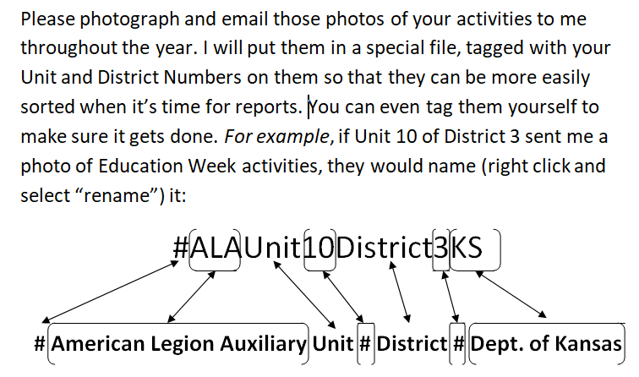

Let’s make President Tracy proud by earning as many awards as we can.

Let’s show off how well we work the programs in Kansas!

Ride the Tide for Veterans and their families!